The journey to becoming a Scaleup City
Tentatively approved for session ‘PARALLEL 5 – Positioning start-ups and SMEs in the 4th Industrial Revolution’, described here:
For some time now, SMEs have been pushed to the side, while startups and of course, the hottest multinationals have occupied most of the attention. However, SMEs remain central actors in all world economies and are of the highest importance for STPs and AOIs. How will the 4th Industrial Revolution impact SMEs specifically? How can STPs and AOIs support the necessary transition of our SMEs? Is there an ideal mix of the companies located in STPs and AOIs according to their size? How will STPs and AOIs enhance the right evolution of companies through their successive stages of development (startup, scaleup, SME, big company…)?

Executive Summary
The innovation ecosystems in Sweden are heavily supporting the startup phase with seed funds, business developers and technical labs support. However, the national export services, banks and venture capital are all expecting to work with midsized and fast growing companies. There is a gap to be filled between startup and scaleup, where the Valley of death is famous, where most startups die without ever reaching the larger markets. It is not the startups that will grow the economy, but the Scaleups.
With the experience of 35 years of innovation and growth support, and being a Swedish science park, where the market in Sweden never is big enough for scaleup companies, Ideon Science Park has started the journey to become a scaleup city. The keys to scaling up being organisational and leadership knowledge, internationalization, funding opportunities, match making and furthermost customer insight and structured feed back loops.

Background
Sweden is frequently ranked as second in the World within Innovation. The Swedish innovation system includes two key success factors to drive the innovation forward; the fact that the IP is owned by the scientist, not the University, by default, and the fact that Sweden is used to a flat organisation model with low hierarchy, making it possible for anyone to pitch in and bring ideas to the table. That creates a culture of a startup employee mindset. And adding to that we have build up an innovation system on national and regional level that fuels the innovation startup environment.
The Swedish national incubator program, to which only the top incubators in the country may apply and be registered, supports with business development, funding and startup support for about 10 Million Euros/Dollars per year. Additionally, the department for innovation holds funds of several million dollars, that may be applied for in different phases of the innovation journey, and the state funds from different departments like growth department, Swedish Energy agency works the same way, adding 60 Million Euros in a pot for energy related innovations.
However, the majority of activities and public funds are directed to the startup phase, all over Sweden. Only in Skåne, the region where Ideon Science Park resites, over 50 different organisations can be found to belong to an unorganised innovation system, that mainly helps the startups. Startups has become something everyone wants to be, or work with.
This is very different from when Ideon Science Park was founded, 1983, as the first science park in Scandinavia. Back then, the founders of the science park and related organisations, in a triple helix constellation, had to invent a system, create organisations and gather the funding that would support the few R&D or startups that started at Ideon Science Park.
This system of seed and growth money to be applied for, was the foundation of the Swedish innovation system, that now has spread into multiple organisations and departments everywhere in Sweden. It is now cool to support new companies and to be an Entrepeneur is to be a hero of the society, which was not the case in the 80s.
Every year about 70 000(note 1) new companies are founded in Sweden, in a population of 10 Million, out of which Y are founded by women. Many companies are innovation companies with some kind of digital or technical service or product. As mentioned in the beginning, Sweden is frequently ranked as no 2 in the World when it comes to innovation. But we are not in the top when it comes to commercialisation. Even if Sweden has produced some Unicorns, the majority of the startups have a real battle to survive and even more to enter the next phase of scaling up.
My thesis is that we need to focus more on the scaleup phase in order to make the most of our innovation strength. This is why Ideon Science Park has decided to start the journey to become THE Scaleup Park in Sweden, or even better, in North of Europe.
What is a scaleup company?
According to Wikipedia there is an OECD definition of Scaleup Companies: A scaleup (company) is a company who has an average annualized return of at least 20% in the past 3 years with at least 10 employees in the beginning of the period (OECD, 2007)(Note 2)
A scaleup can be identified as being in the "growth phase" life-cycle in the Millers and Friesen (1984) life cycle theorem, or the "Direction phase" in the Greiner growth curve.
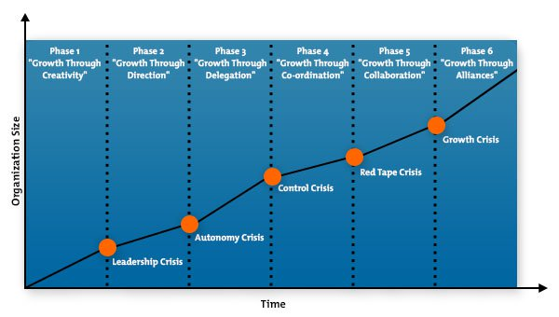
The importance of scaleups and the rise of their terminology can be found in the study of the World Economic Forum which found that not all startups make it big, but the ones that do greatly impact society by means of new technology, services and increased employment ^{(Note3)}
To aid this rise, instead of large startup incubators policy makers are more and more focusing on scaleups since they are the ones that add value.
Note 1: https://www.ekonomifakta.se/fakta/foretagande/entreprenorskap/nystartade-foretag/
Note 2: https://en.wikipedia.org/wiki/Scaleup_company
Note 3: https://www.weforum.org/agenda/2017/03/start-ups-entrepreneurship-scale-ups-latin-america/

World Economic Forum says Startups won´t grow the economy, but Scaleups will
In an article in World Economic Forum (Note 4), standing on several scientific researches, it is stressed that “for entrepreneurial activity to translate into economic growth, we need to focus less on the “start” and “small” side of things and more on how those companies of all ages, sizes and sectors scale. Why? Because research (see here, here and here) clearly shows that it is relatively high-growth firms – what we call “scale ups” – that are the real generators of jobs, taxes and wealth. Contrary to the myth, small businesses and start-ups only generate these benefits if they then go on to grow.”
As a Science Park we need to understand how to nurture growth, what key success factors are needed, and what service could be provided in order for our companies in the park to scale up in the best possible way. Perhaps it is a luxury issue in Sweden, that for so long has nurtured the startup culture, that it now is a bit saturated, but as shown below, even if Sweden is ranked high within innovation, when it comes to ambition of scaling, we are not that highly ranked at all.

Swedish competitiveness
So – in Sweden everyone wants to be and entrepreneur, and work in a startup company. But not everyone in Sweden wants the startup to become super large. Is it in our culture to not want too much organisational charts, thinking inside the box, KPIs and middle management, but rather in a consensus way work in a safe, open and creative climate – like that of a small company?
Here is a chart showing the Swedish competitiveness within innovation (Note 5). A country’s competitive environment includes its conditions to facilitate the ability to start a business, to develop and introduce innovations, and to grow businesses.
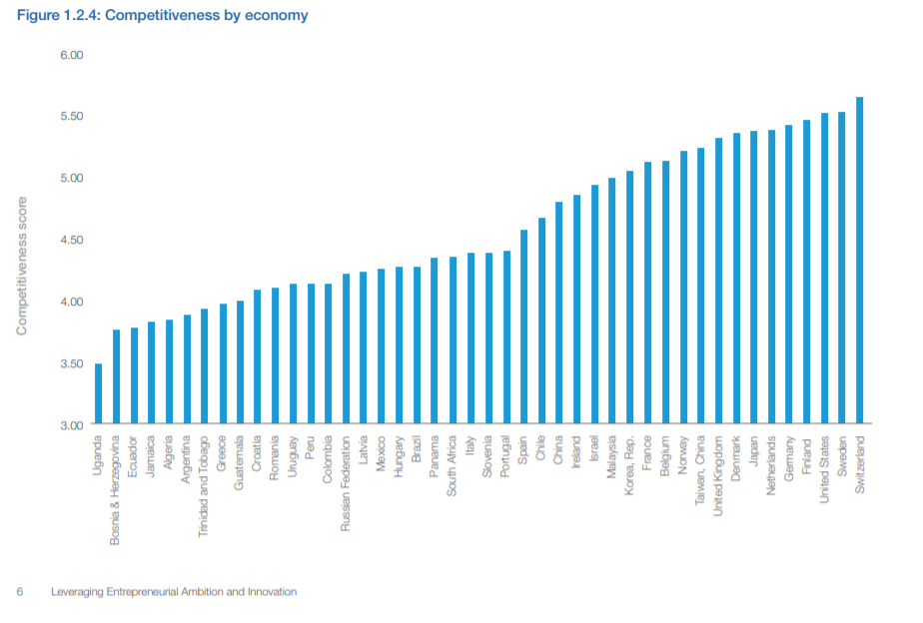
Note 4: https://www.weforum.org/agenda/2017/03/start-ups-entrepreneurship-scale-ups-latin-america/
Note 5: http://www3.weforum.org/docs/WEFUSA_EntrepreneurialInnovation_Report.pdf
And here is a chart showing that the ambitions of the Swedish startups are lower than the competitiveness gives us reason for. (Ambitious companies wants to grow to employ 20 persons within 5 years time. (Note 6)
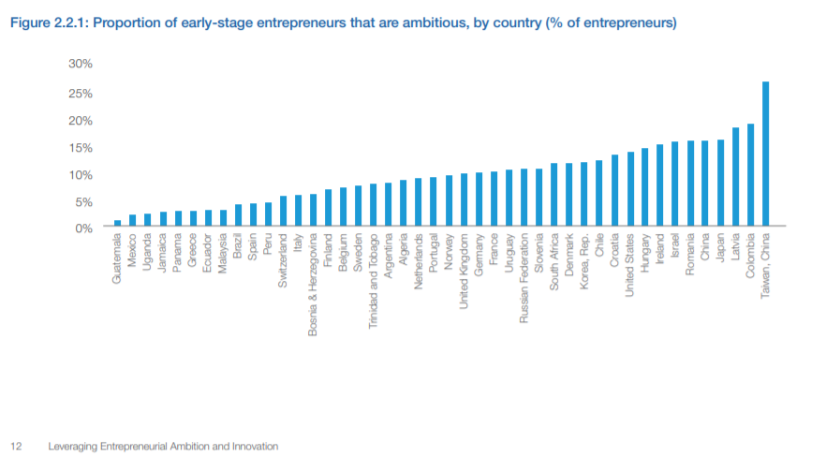

If we break it down to gender level, we see that men tend to have higher ambitions with their company than women, but we must take into account that we need to “listen-up” the women, they are not trained or accepted to have growth ambitions and tend to lower the ambitions when asked. When you look at the figures, companies with a 40/60% equality and diversed leadership do better than those who do not.

Note 6: http://www3.weforum.org/docs/WEFUSA_EntrepreneurialInnovation_Report.pdf
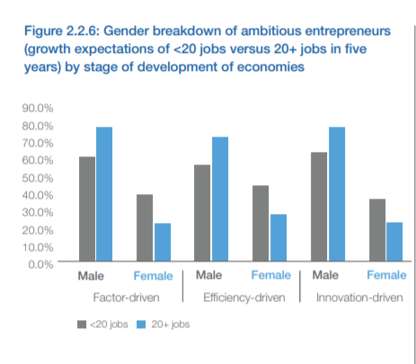

What we learnt from working with questioning the way incubation most often supported men, was that while men triggers on the money or technology factor, women triggers on the impact factor.
Here are some words form a female scaleup leader: (Maha Arayssi Rifai, Beesline (Lebanon) Company Description: Founded in 1993, Beesline is a rising brand of natural personal care products developed and produced entirely in Lebanon)
Why is high-growth entrepreneurship important for your country? In a nutshell, entrepreneurship is the pulse of economic growth.
What advice do you have for other ambitious founders across the world? Always be hungry to learn. And remember— if plan A doesn’t work, there are 25 more letters in the alphabet. Meaning that the road of entrepreneurship is hard especially in poor societies. Ambition is not sufficient to succeed. You will need a Complicated Relationship patience, perseverance and above all the faith that what you do will have some positive repercussion on your society to begin with and maybe later on, on the whole world.
(Note 7)

Note 7: http://www3.weforum.org/docs/WEFUSA_EntrepreneurialInnovation_Report.pdf

Swedish national strategy
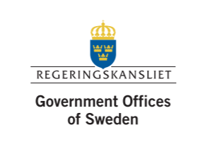

New studies, from the OECD among others, reveal that up to three quarters of productivity development in industry can be attributed to innovation (Note 8)
OECD stresses that an innovation policy with a challenge-led perspective requires a system perspective. Climate changes and sustainability issues will continue to create new market opportunities. The ambitious Swedish targets for e.g., reduced carbon emissions may, according to OECD, work as a facilitator, together with targets for renewable energy and sustainable development.
And I quote:
The Swedish “Vision 2020
- People and actors, by being more innovative, to contribute solutions to big societal challenges, in Sweden as well as globally.
- Businesses and environments, by being more innovative, to create value, increase their competitiveness and attract expertise, investments and cooperation partners from around the world.
- Actors in the public sector and their partnership with private and civil society organisations, by being more innovative, to supply public services of a high quality and efficiency.

Sweden therefore needs to:
• Develop internationally competitive conditions for both domestic and foreign businesses to develop their operations in Sweden and deliver offers with a high added value on global markets.
• Create good conditions for strategic cooperation between global business groups in Sweden, smaller enterprises, universities, research institutes, public organisations etc. (this is what Science Parks do)
• Facilitate the growth of small and medium-sized enterprises with growth ambitions, to grow through export and other forms of internationalisation. (And here is how we must step in and help even more)
• Take advantage of linguistic and cultural expertise among foreign nationals and people with international experience in order to promote trade.”

Note 8: https://www.government.se/contentassets/cbc9485d5a344672963225858118273b/the-swedish-innovation-strategy

Open innovation – something Ideon has an expert team on
The Swedish Strategy also includes a focus on Open innovation. Open Innovation is about businesses combining knowledge and ideas developed internally and externally. Open innovation implies that businesses actively involve external actors in their own innovation work. Other forms of incentives for sharing knowledge, such as acknowledgement and the desire to make a difference are becoming ever more important. Many businesses, from global business groups to smaller enterprises, are re-organising their research and innovation activities towards open innovation. The level of investment in innovation can be retained, but the work is carried out by a small number of in-house personnel in collaboration with external actors in universities, research institutes and other businesses, as well as with individual users and experts. The networks and relation of people, businesses and other organisations are therefore core factors in open innovation processes. The development of networks is facilitated by the mobility of people and efficient digital tools for social interaction.
Identify the areas and sub targets in the system of environmental objectives, where eco-innovation has in a broad sense a particularly important role in achieving the generational goal and to develop the environmental quality objectives.
Regional Strategy Skåne – 2020
The Region Skåne ordered a study 2016 on how to become the most innovative region 2020. The understanding of the study was that relatively large resources were put in to support the early stages of a company´s journey, like picking up ideas that have potential to become new companies, but the support for companies in the scaling up phase was weak. It also showed that the structure for finding potential service innovations was weak, that the availability of funding for growth phase companies was small and that the need for trend and world economy analysis was large, but poorly supported. And finally it showed that the coordination of the activities of the different actors, as well as an increased internationalisation of the supportive organisations was needed. (Note 9)

Note 9: https://utveckling.skane.se/siteassets/publikationer_dokument/internationell_innovationsstrategi_for_skane.pdf

Here is an image of the South Swedish Innovation Landscape 2016 (Note 10)
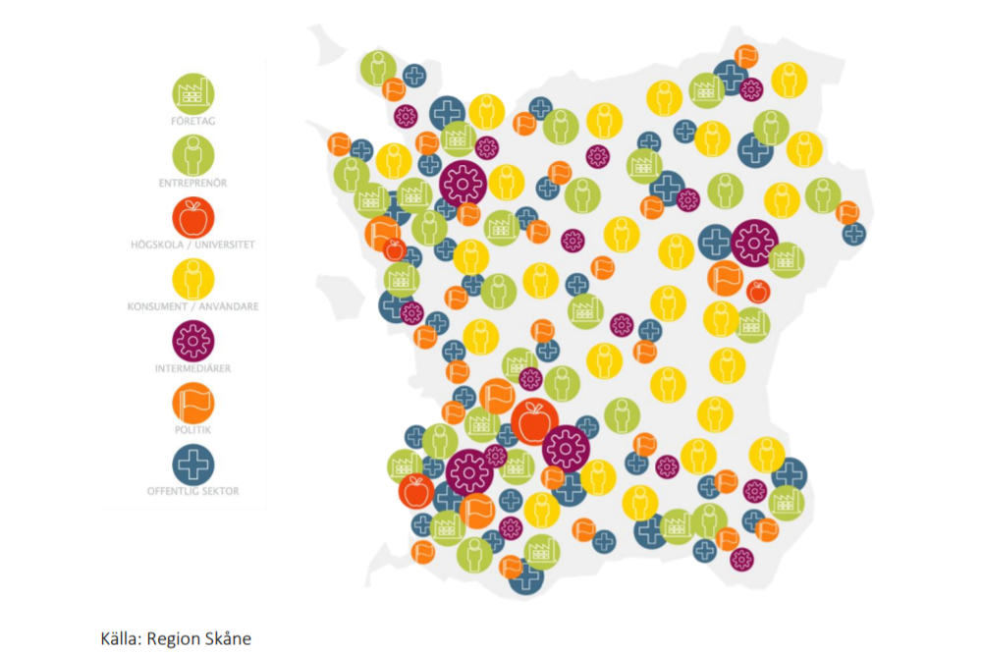
It can be seen that many entrepreneurs and businesses are spread all over the regione, but that the Universities and intermediaries, like science parks are focused to the west, closer to Copenhagen. Still the landscape is a widely spread innovation support mainly towards startup/entrepreneurship.
In Skåne, the regional development yearly budget at 20 Million Euros is scaled up with the help of local, national and European cofounding to a budget of 80 Million Euros per year. (Note 11)
Here, the science parks could be really important in understanding the needs for scaleup wannabes/startups and step in to take a more proactive role in the scaleup support system. Today there is no such connection or formal mission in Skåne, our region. But that does not mean it can´t be changed.
All successful Swedish companies are international
Sweden is a tiny domestic market. We only have 10 Million inhabitants, it is like a city in other countries. And yet we have large companies and brands like Ericsson, IKEA, H&M, Spotify and more. The only possible way for a Swedish startup to be large and successful, is to be international and have multiple markets. And to be relevant in other markets than your own, you need to be excellent in understanding the other markets´ needs, infrastructure, culture, and monetary situation. The Swedish people need to be constantly curious of the rest of the World.

Note 10: https://www.skane.se/Public/Protokoll/Regionala%20utvecklingsn%C3%A4mnden/2016-12-05/Nul%C3%A4gesanalys%20f%C3%B6r%20Sk%C3%A5nes%20regionala%20innovationssystem%202009-2016/Rapport%20Funktionsanalys%20Sk%C3%A5ne%2028%20nov.pdf
Note 11: https://utveckling.skane.se/siteassets/publikationer_dokument/internationell_innovationsstrategi_for_skane.pdf

Scaleup City thus have to include
- Tools and connections to let the startups/scaleups understand the demand of the market

To support the scaleup companies with understanding the demands and make faster adopted innovations for growth, we need to make the engineers/innovatiors meet the market at an earlier stage than they would have chosen themselves – and keep asking the customers through the scaleup phase about important facts around the problem/possible solution/design and best business model for the customers. We need to bring some behavioural science and design thinking into the park, and teach the engineers/innovators how to put the questions out there, in order for them to get the most fruitful feed back, to be able to make increasingly better innovations, that are faster accepted by the market and thus create faster scaling up grounds.

What we have done – the PEP talk platform:
Together with students from the behavioural science faculty at the Lund University, Ideon science Park developed a platform for prelaunch feed back. It connects innovators to feed backers, but may also serve as a sneak peak for investors, future employees and future partners in or around the park. We intend to see the park employers, as well as the students around as the primary feed backers, and they are today around 50 000 people. We call it Prelaunch Evaluation Platform, PEP (Join the PEP talk) and may roll it out to other markets or science parks in the future.
Ideon science Park also needs to build up and care for the relationship with Science Parks in other continents and in the rest of Europe, to be able to support with international connections and insights or needs. This is why we are partners today with Chinese, Nigerian and Colombian science parks and Universities (these are large markets), and we are very interested in starting relationships with markets closer to us, like Denmark, Netherlands, Germany and Poland.

- Leadership training/development for transformational leadership
To support the scaleup companies Ideon Science Park also need to address the fact that leading a startup is very different from leading a scaleup. There is need for more structure, delegated responsibility, skills in recruiting and finding funding as well as mastering increased sales and production / delivery. In fact the transformation from leading a startup to leading a scaleup is painful and goes against most of the “freedom, lifestyle” entrepreneurs that have entered the entrepreneurship or a small team to avoid the presence of bosses, and to feel more important in all decisions. Only some will actually transform and enjoy it.

What we have done – Sharp Minds sessions and Mettorship program, leadership training & support: Ideon Science park has, with the 35 year history, many successful scaleup leaders in the park, or nearby, and they tend to want to contribute back to the community. In sessions called “Sharp Minds sessions”, we interview them and try to learn the key success factors in front of an audience in the park. The sharp minds are also part of the Ideon Mentorship Program, where scaleup leader wannabes in the park, may compete to win one year of mentorship with one of the mentors. 2019 is the second year of the Sharp minds and the Mentorship program.

We are also forming actual Scaleup leadership trainings together with a business school partner of ours. We want to offer the training to a 50% fee, where the park stands for the rest.

Additionally we have entered a partnership with a digital leadership support, Rebbel Mountain, and together we form the blocks of content is needed for a scaleup leader to be able to learn what to focus on, via e-learning and coaching. This is being tested by 5 companies during the spring, and adaptation to the feed back will be made before the rollout in the autumn.
- International or larger company connections/partnerships/exposure for international sales
In order for the scaleup companies in the park to quickly get out on an international market, we need to make sure the park is international, with a large percentage international employees. Today we have about 30% internationals and about 60-100 internships in the park every year from abroad.
What we have done – Match-Making, UN partnerships and training. Apart from the relationships with our international Science Parks partners, we constantly receive international delegations and try to match our companies in the park to their interest, and in our Open Innovation expert team, we match the large with the scelaups/startups to form ground breaking innovations.

In 2018 we also formed a partnership with the UNOPS (UN Operations) that has, buy the support of the Swedish government, opened a UNOPS Global Innovation Center Ideon at Ideon Science Park. This centre will be connected to 10-15 other centre across the globe, and will transfer the global needs for innovation from emerging markets and catastrophe areas. The GIC Ideon will connect all Swedish innovation system, and support the startups/R&Ds in the places of the largest needs, and match make new innovation constellation that may bring solutions to the largest needs in other places in the World. Parntering with large multinational companies like Sony, Volvo Cars and more, we hope to build an investment fund to really make a difference.
Connected to this We intend to train the small and medium sized (and the large if needed) in how to become ready for making business with UN, and eventually other international clients with the same high standard demands. We hope to have a UN park with majority of the companies complying with the UNGC, aware of how their business idea contributes to the global agenda 2030, and comply with our own Ideon code of conduct. Year 2019 is the start.

- Funding for growth phases. Private and public (left to sort out)
In order to really scale, most companies need external funding in the growth phase. Ieon Science Park needs to put the companies in touch, and in front of, investors that are looking for this phase to invest in. One example is our partnership with the Swedish Energy Agency and several incubators, energy clusters and Lund University school of technology. The companies in this list of energy related innovation companies are both small and midsized, may have had investments before but in need for another round. The team match makes them to correct possible funds from the Agency, but also with other investors or partners that may help them scale.

- Talent attraction activites for fast recruitments
The perhaps most sensitive issue when scaling up is finding the talents needed, fast enough. The companies that grows in the park are together in need of 400 programmers of different kinds, every year. If they can´t find them here, they might have to move somewhere else.

Ideon has met this with several action within talent attraction. In one partnership we bring incoming academics into a speed training to become programmers and put them into internships in the park. In another partnership we make surethe master students in greater Copenhagen area invited to match making events twice a year. In a third partnership we host an IT fair with over 650 jobs by 60 companies are exposed, and we investigate how to support the job permit and international training of talents, to meet the needs of our companies.

As a conclusion – this is a journey that we only started, and we call for other science parks to take on the role of being a scaleup city/park. Let´s help our country economies to grow by taking the science park role one step further, from science, to startups, to scaleups and beyond.

Mia Rolf
CEO
Ideon Science Park

